Dux

Dux (Commander in Latin) is a real time strategy orientated game where the player takes control of a war commander, general or any other military leader. The concept could even be adapted to allow the player to interact with the actual battle in third person. Following the stereotypical rules of most RTS games, the player must win the battle or suffice the winning conditions.

The voice recognition would be implemented through a series of real time commands that are pronounced to control the player’s units depending on the current state of the battle. Here’s an example using the infamous ‘Lord of the Rings’ Helm’s Deep Battle as a level:

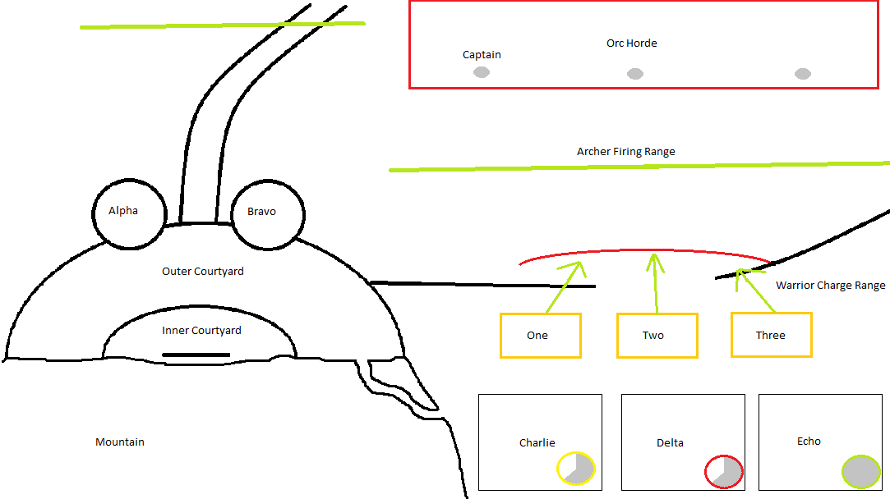

In this example there are two main types of unit, Archers (Black, Phonetic) and Warriors (Orange, Numerical). Prior to actual battle the player must set up the appropriate placements of their units

Setup

During the setup the player must control and manage their forces by commanding them:

* Archers: Occasionally fire, wasting arrows and missing targets as they are out of range. The Commander must pronounce the squad name e.g. “ALPHA”, followed by the command “STEADY”.
* Warriors: Can become impatient and tire. The Commander must pronounce the squad name “ONE” followed by the command “HOLD”.

The yellow indicator will visually inform the player of a unit’s restlessness.

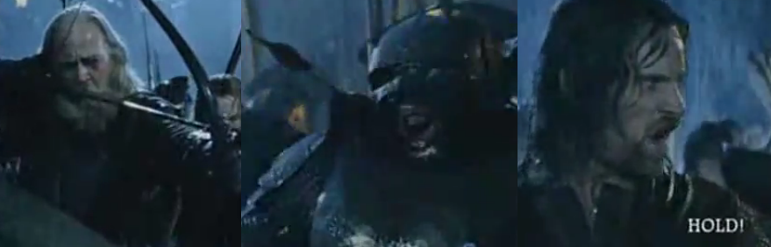

Battle

Actions

Once battle has begun the player must also command their unit’s to attack or defend efficiently:

* Archers: Fire on command, volleys must be effectively timed to maximise target hits. The player must pronounce the name of the squad e.g. “ALPHA”, followed by the command “FIRE!”
* Warriors: Can attack, defend and charge. The charge range is limited and damage to enemies can be increased by a full length charge. If a unit charges and does not encounter an enemy, then they become tired and significantly weaker, thus a Charge must be effectively timed. The Commander must pronounce the squad name e.g. “ONE” followed by the command “ATTACK!”, “DEFEND!” or “CHARGE!” Alternatively, the player could be informed when a charge is imminently ready and the player could command anything e.g. “ANNIHILATE!” to activate the charge.

The red indicator will visually inform the player of a unit’s reload time, turning green when archers are ready to fire again.

Units can also be commanded to “FOCUS” fire on specific units, “RETREAT!” to a specific area e.g. or “PUSH” to a specific area e.g. “OUTER COURTYARD”.

Movement

Units can be commanded to move to specific areas, specific grid references within an area or to support another unit. The player must pronounce the squad name e.g. “ALPHA”, the command to “MOVE!” or “SUPPORT!” and either an area e.g. “OUTER COURTYARD”, grid reference “A-3” or squad name “BRAVO”.